
Grain items offered on menu are whole grain.
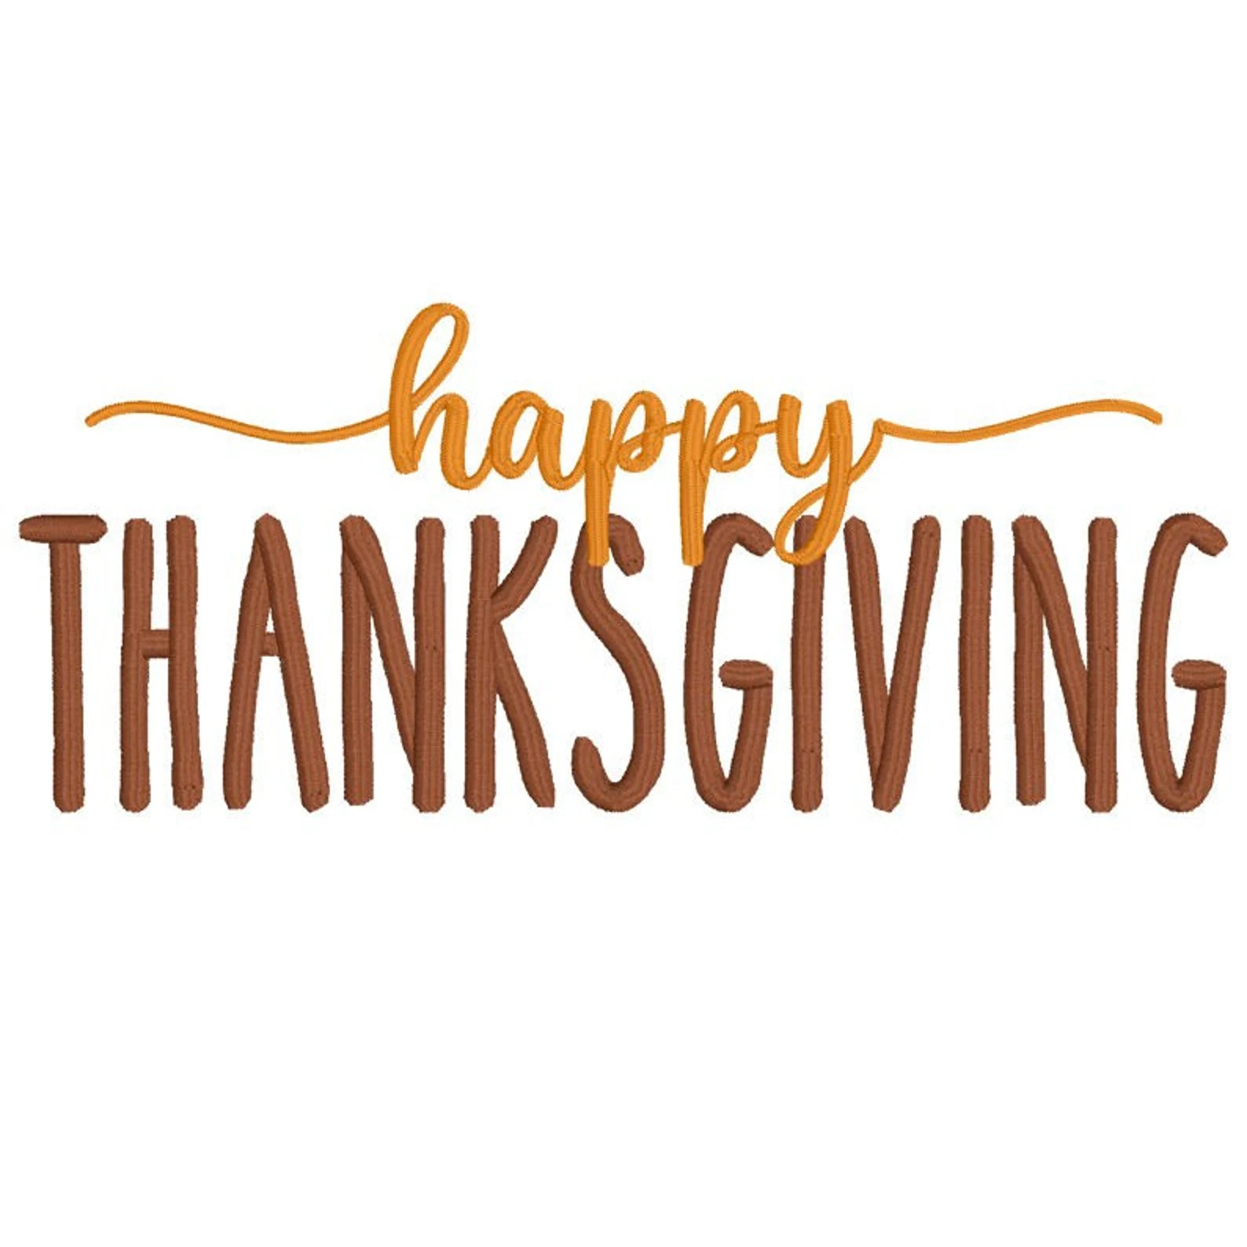
Menu is subject to change due to product availability.
“This institution is an equal opportunity provider.”

NOVEMBER 2025

Veteran’s Day
No School

Skim and 1% milk offered daily.

Turkey & Dinner Roll
Mashed Potatoes & Gravy
Steam Veggies
Sliced Peaches

Beef & Bean
Cheese Nachos
Sliced Peaches

Cheeseburger
Corn
Pear

Baked Chicken Sandwich
Sliced Cucumbers
Fruit Mix

Grilled Ham & Cheese Sandwich
Celery
Diced Pears

Pepperoni or Cheese Pizza
Broccoli
Applesauce

Pepperoni or Cheese Pizza
Broccoli
Fresh Apple

Orange Chicken
Steam Rice
Cucumbers
Diced Pears

Pepperoni or Cheese Pizza
Broccoli
Applesauce

Popcorn Chicken Bowl
Cucumbers
Diced Pears

Baked Chicken Nuggets
Mashed Potatoes & Gravy
Pear

